**Chapter 1**

**CHAPTER 1**

**INTRODUCTION**

Nowadays, computers are a basic need for businesses and companies. It helps in a way that it makes work more productive. Computer software like a payroll management system is an important thing that a company should have because it helps a lot in many ways, such as efficient and accurate salary calculation, manipulating data, etc. Having computer software may help a company grow and be more competitive.

A manual payroll system typically requires a great deal of paperwork. And manual processes also create an administrative burden for the company’s HR staff. The payroll system represents an accounting function business owners use to pay employees. A payroll management system will reduce the burden on the company’s staff, increase employee satisfaction, and lessen complaints. The payroll system within the company is primarily focused on the employees, staff, accountant, and HR.

Timekeeping is a fundamental aspect of the payroll system, serving as the foundation for accurate, reliable, and timely employee compensation. Traditionally, timekeeping involved manual methods such as paper timesheets or punch cards, which were time-consuming to manage and prone to errors such as inaccurate payroll computations caused by manual methods like paper timesheets or spreadsheets and the risk of time theft where employees engage in practices like buddy punching (clocking in or out on behalf of a coworker) or inflating hours of work. The absence of a reliable payroll system with timekeeping can result in a variety of negative consequences, including missed calculations, compliance risk, operational inefficiencies and so on.

With a timekeeping system, the company can ensure precise calculations of employee work hours, reducing errors and discrepancies in payroll processing. The timekeeping system streamlines the payroll process, saving administrative time and effort previously spent on manual data entry and verification. With this system, it will organize and simplify the payroll functions by keeping track of the working hours performed by the employees, the computation and filing of withholding taxes, salary deductions, and

the overall computation of employee wages. This document provides essential information about the aim of the project, including its scope and limitations, project overview, system architecture, and system features.

**Problem of the Statement**

This system, entitled "Timekeeping with Payroll System," is designed to find out and solve the problems regarding this topic.

The frequent effects of inaccurate calculations of staff time and overtime at work can lead to decreased productivity due to factors such as fatigue, low morale, increased absenteeism, work speed, and rework caused by mistakes. and defects, and the worst are job burnout and the employee going AWOL. The company may not have enough budget to develop an automated payroll system. The most common issue with using a manual time tracking system is its inaccuracy. It is prone to errors such as misstated hours, miscalculations, and inadvertent errors, leading to payroll discrepancies. and potentially underpaying or overpaying employees, and this can amount to losing time tracking records.

**Solution Overview**

This system, entitled "Timekeeping with Payroll System," is where we will find out what possible solutions we can do.

Having automated time tracking with a payroll system is a very important thing in a company because it contains details about their attendance; they also track who is absent and present that day; they track the schedule and overtime hours of the employee; and above all, they manage the personal information records of the employees and their salaries properly. The features that will be installed here are the creation of a mobile application for scanning the attendance of employees, a payroll system with salary calculation, deduction, overtime pay, holiday or bonus pay, and an employee information management system.

**Target Audience**

The payroll system will be managed by the company’s HR and accountant and the time keeping system will be used by all of the company’s employee.

**Deliverables**

Here are some of the lists that users will see at the end of this system.

1. Time tracking via QR code for employee attendance scanning via mobile application. Here, the employee generates a QR code containing his personal information and taps it on the scanner to confirm that the employee is present that day.
2. The automated payroll system is designed to efficiently manage employee personal information, including attendance records, salary calculations, and deductions.

**Objectives**

In the realm of modern workforce management, the integration of payroll systems with timekeeping functionalities has become indispensable for organizations striving for efficiency, accuracy, and compliance in their payroll processes. A payroll system with timekeeping seamlessly combines the functionalities of tracking employees’ attendance, calculating wages, and processing payments, thereby serving as a cornerstone in the realm of human resources management. The objectives of the study are the following:

**Primary Objective**

1. **Accurate Payroll Processing**: The primary objective of a payroll system with timekeeping is to calculate employee earnings accurately, taking into account elements such as normal hours worked, overtime, leave taken, and any other applicable compensation components. Accurate payroll processing ensures that employees are paid appropriately and on time, which is critical to preserving their satisfaction and trust for the organization.

**Secondary Objective**

1. **Efficient Time Tracking**: A secondary goal is to efficiently track employees' work hours and attendance. This includes recording clock-in and clock-out times, tracking breaks, and managing schedules. By precisely documenting time spent, the system aids in assessing staff productivity and compliance with labor requirements.
2. **Enhanced Efficiency and Cost Reduction**: Implementing a payroll system with timekeeping is intended to streamline payroll procedures and reduce administrative burdens. Automation of operations like payroll calculation, tax withholding, and report preparation increases operational efficiency and saves HR employees’ time. Furthermore, decreasing manual errors and enhancing data correctness can result in cost savings on payroll corrections and compliance-related issues.
3. **Data Management and Reporting**: The payroll system should allow for excellent data management and reporting capabilities. It should keep precise records of employees' earnings, deductions, and taxes for each pay period. Furthermore, the system should provide a variety of reports, including payroll summaries, tax returns, and employee earnings statements, which are required for financial management, auditing, and decision-making.

**Success Criteria**

1. **Accuracy of Payroll Computation:** Payroll computation accuracy is a key success criterion. This entails ensuring that employee earnings are accurately computed, including normal hours, overtime, leave deductions, taxes, and any other relevant compensation components. Accuracy reduces errors in employee payments, which is critical to employee confidence and happiness.
2. **Efficient Timekeeping:** The system should efficiently track employee work hours, attendance, and leave, giving precise data for payroll processing and compliance. Efficient time monitoring reduces disparities between recorded hours and aids in assessing staff productivity and performance

**<for inclusion and exclusion: features need to be finalized>**

**Scope**

The proposed system Payroll system with timekeeping for I-Move courier services Covers many aspects of payroll and timekeeping process. This includes payroll calculation, employee management, Daily attendance rate, and time tracking integration. The system will convert the current payroll system of the company to Web application program.

**Inclusion**

**Exclusion**

**Technologies Used**

**Programming Language**

**PHP** - This is serves as backend language of our system. It handle task such as processing timekeeping and payroll data, interacting with database, store and retrieve information and lastly handling rest API.

**Framework**

**React Native** - React Native is likely used for the frontend development of the mobile application. It provides efficient user interface experience and facilitate the integration of various functionalities related to timekeeping with payroll system.

**Library**

**JQuery** - JQuery is likely used for frontend development, especially on our web application. It also utilize and enhance the user interface experience and provide dynamic interaction on our timekeeping with payroll.

**Tools**

**Visual Studio Code (IDE)** - Visual studio code is our choice of IDE to build the system, offering features such as syntax highlighting, debugging console, many extensions available for our needs.

**Database**

**XAMPP (Database)** - provides a local server environment for our development. It allows us to run PHP script and interact with databases and test our web application locally before deploying them to a hosting server.

**Architecture**

**High-Level Overview**

A timekeeping payroll system is a method for tracking employees in a firm and better monitoring job attendance. Each employee will have their own mobile timekeeping app that includes their personal information. It will link with the payroll system, which includes a QR code for attendance tracking through timekeeping. They can tap the QR Code on the system, and the employee will be notified whether they are present, or late that day.

**Components**

**Mobile Timekeeping App:**

* Employees can use their smartphones to register attendance by scanning QR codes at appropriate areas.
* Employees may easily access attendance records, leave requests, and calendars using an intuitive interface.
* Transmits attendance data securely to the backend system for processing and connection with payroll.

**QR Code Generation and Management:**

* Creates unique QR codes for recording attendance at various locations, including office doors and project sites.
* Manages QR code distribution and positioning for employee convenience and accessibility.

**Backend Integration:**

* Processes attendance data from mobile app to identify employee status (present, absent, late). Automatically updates employee attendance records and incorporates attendance data into payroll calculations.

**Payroll System:**

* Manages employee payroll data, including attendance records, working hours, and compensation rates.
* Utilizes the integrated attendance data to accurately calculate employee salaries, factoring in attendance status (e.g., absence deductions, overtime calculations, salaries).

**Chapter 2  
Features**

**Features**

Here are the capabilities available in the payroll with timekeeping system's web-based and mobile application. Each feature will describe its role and functions.

**Web based Payroll System**

Dashboard – This reflects the overall number of workers, attendance, requests, overtime, and leave in the organization. These features normally display the total quantity of data input here.

Managing Employee – The employee listings are displayed here. The only person who has the authority to possess it is the one granted by the management. The authorized user can add, edit, update, and remove.

Timesheet – The mobile application displays employees’ time–in and time-out. This happens in real time and has an instant impact on their application as well as payroll. The human resources department will utilize this information to assess how many employees were missing, present, or late.

Approval – These features indicate employee requests for sick leave, casual leave, maternity leave, unpaid leave, and many more. This allows only those with the authority to approve employee requests that are based on the manager’s decision and human resources.

Payroll – These aspects cover all calculations, such as wages and deductions like SSS, Pag-Ibig, PhilHealth, and others. Here you may also see how the reduction is calculated; if an employee is missing, present, or late, their salary will be reduced. This features can also generate payslip.

Settings – This functionality allow the user to manage the types of employee, employee position, daily rates, holidays management, deductions and incentives.

**Mobile App Timekeeping**

Attendance Monitoring – In these features, the Time In, Time Out, and Date submitted by employees may only be seen in their own accounts, and no one else will be aware of it.

QR Code – The only thing visible in these features is a QR code containing each employee's personal information, which will act as their attendance when tapped on the scanner.

Request – In these features, any employee may seek sick leave, casual leave, maternity leave, unpaid leave, and other benefits, and human resources can view all of those who have sought them through the application once they have been approved on the web.

**Chapter 3  
User Guide**

**Troubleshooting**

**Technical Documentation**

**Installation Guide**

**Configuration**

**API Documentation**

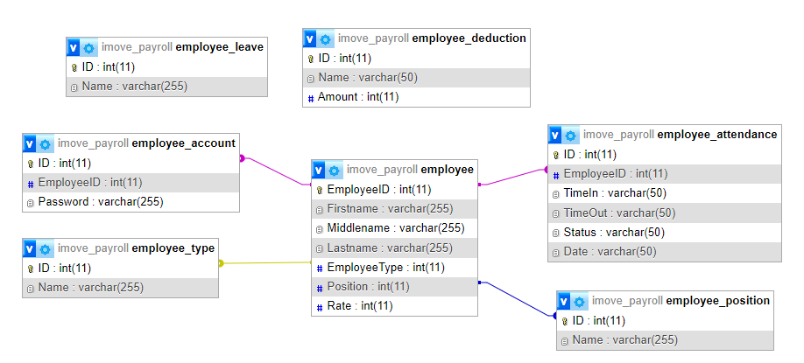**Database Schema**

Figure 1. Database Schema

**Code Documentation**

**Chapter 4**

**Testing**

**Deployment**

**Maintenance**

**Chapter 5**

**Conclusion**